SET 16 – CUSTOMER DEMOGRAPHICS ANALYSIS
Aim
To analyze customer demographics using a bar chart, pie chart, and table in R.
Algorithm
- Create the customer demographic dataset.
- Store Customer ID, Age, Gender, and Income.
- Create a bar chart to visualize customer ages.
- Create a pie chart to show gender distribution.
- Display the demographic data in a table.
- Add suitable titles and labels.
R Program
library(ggplot2)

customer <- data.frame(
ID=c(1,2,3),
Age=c(28,35,42),
Gender=c("Female","Male","Female"),
Income=c(50000,60000,75000)
)

ggplot(customer, aes(factor(ID), Age)) +
geom_bar(stat="identity") +
labs(title="Customer Age Distribution",
x="Customer ID", y="Age")

gender <- table(customer$Gender)

pie(gender,
labels=paste(names(gender), gender),
main="Customer Distribution by Gender")

print(customer)
OUTPUT:
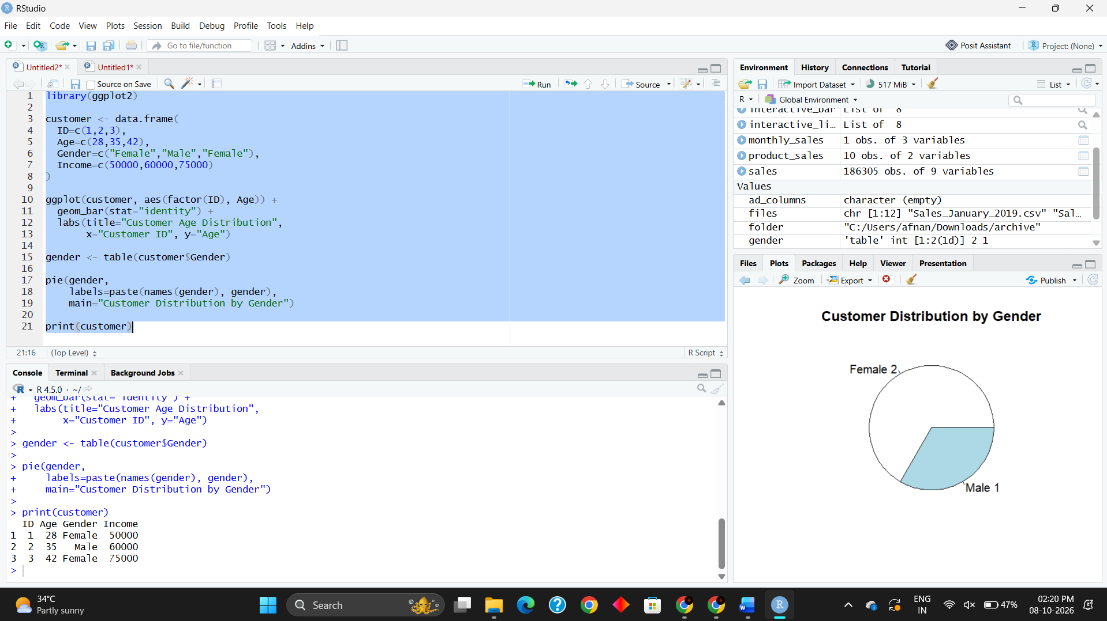
Result
The bar chart successfully represents customer ages, while the pie chart shows the gender distribution. The table displays the complete customer demographic information.

